1)

#include<stdio.h>

int main()

{

int n,i,b[100];

scanf(“%d”,&n);

while(n>0){

b[i]=n%2;

n=n/2;

i++;

}

for(int j=i-1;j>=0;j--){

printf(“%d”,b[j]);

}

return 0;

}

Output:

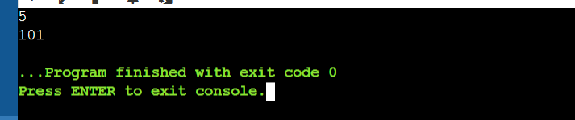

2)

#include<stdio.h>

#include<ctype.h>

int main()

{

int vowels,consonants;

char string[100];

char \*ptr;

printf(“Enter the string:”);

fgets(string,sizeof(string),stdin);

ptr = string;

while(\*ptr){

char ch=tolower(\*ptr);

if(isalpha(ch)){

if(ch==’a’||ch==’e’||ch==’I’||ch==’o’||ch=='u'){

vowels++;

}else{

consonants++;

}

}

\*ptr++

}

printf(“\nNo of vowels:%d”,vowels);

printf(“\nNo of consonants:%d”,consonants);

return 0;

}

Output:

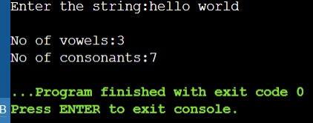

3)

#include<stdio.h>

void add(float,float);

void sub(float,float);

void divi(float,float);

void mult(float,float);

int main()

{

float a,b;

char o;

printf(“Enter teh operator(+,-,/,\*):”);

scanf(“%c”,&o);

printf(“Enter the two operants:”);

scanf("%f %f",&a,&b);

switch(o){

case '+':

add(a,b);

break;

case '-':

sub(a,b);

break;

case '\*':

mult(a,b);

break;

case '/':

divi(a,b);

break;

default:

printf("!!Enter a valid operator!!");

}

return 0;

}

void add(float x,float y){

printf("%.2f",x+y);

}

void sub(float x,float y){

printf("%.2f",x-y);

}

void divi(float x,float y){

if(y!=0)

{printf("%.2f",x/y);

}else{

printf("Division with zero is undifined");

}

}

void mult(float x,float y){

printf("%.2f",x\*y);

}

Output:

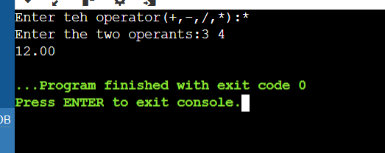

4)

#include<stdio.h>

int main()

{

int n;

printf("Enter number of rows:");

scanf("%d",&n);

for(int i=0;i<n;i++){

for(int j=0;j<n-i-1;j++);

{

printf(" ");

}

for (int j = 0; j < 2 \* i + 1; j++) {

printf("\*");

}

printf("\n");

}

for (int i = n - 2; i >= 0; i--) {

for (int j = 0; j < n - i - 1; j++) {

printf(" ");

}

for (int j = 0; j < 2 \* i + 1; j++) {

printf("\*");

}

printf("\n");

}

return 0;

}

Output:

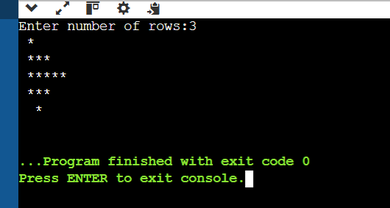

5)

#include<stdio.h>

int main(){

char str[100];

int length=0;

printf("Enter the string:");

fgets(str,sizeof(str),stdin);

char \*ptr=str;

while(\*ptr!='\0'){

length ++;

ptr ++;

}

printf("%d",length);

return 0;

}

Output:

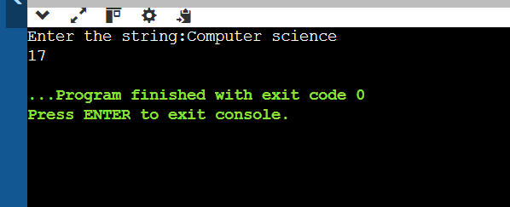

6)

#include <stdio.h>

int gcd(int x, int y) {

if (y == 0) {

return x;

}

return gcd(y, x % y);

}

int main() {

int a=56,b=98;

printf(" GCD is %d\n", gcd(a, b));

return 0;

}

Output:

